Bangkok -Kanchaburi 5day4night (private)
Highlight: Damnean saduk floating Market / Safari Park /Dinner Float house as the sunset

Tour code: KAN -05
Itinerary
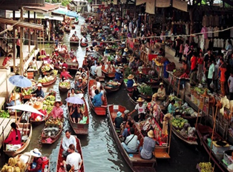
Day1: ARRIVE Bangkok Airport for your flight departure to Bangkok
- Meet and great at the airport with the professional tour guide
- Send to Hotel check in, Shopping Joodfair Night market Dinner by their own

Day2: Bangkok -Dannean saduk -Kanchanaburi (Breakfast /lunch /Dinner)
- Dannean saduk floating market, Mae klong railway station, lunch at local restaurant
- Lunch at the restaurant
- After to Kanchanaburi (approx. 1 hrs.)
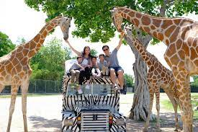
- Safari Park Kanchanaburi: take a tram ride into the zoo, explore the park and experience wild world animals, then continue to enjoy Elephant show and Crocodile Shows (excluding Jeff car** Is Optional)
Afternoon tea at The Village Café * Complementary 1 drink
Dinner at the restaurant
- Shopping Kanchanaburi Night market
- Check-in at Kanchanaburi Resort

Day3: Kanchanaburi (Breakfast / Lunch /Dinner)
- Breakfast at hotel
- Experience train trip pass about 1.30 hrs at Death railway and over the Bridge of River kwai and transfer to Krasae Cave station and visit to Tham kasae cave temple,
Lunch at local restaurant,
Malika Village -Malika R.E.124 Village is a cultural-tourist attraction where you can experience Thai traditional lifestyle
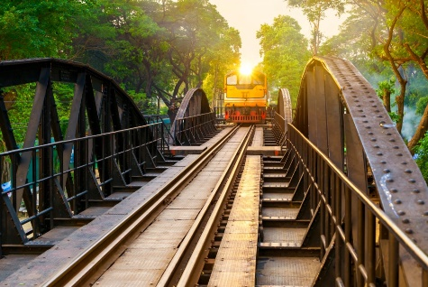
- River Kwai Sky Walk — A scenic glass bridge offering breathtaking panoramic views where the Kwai Noi and Kwai Yai rivers meet. Visitors can enjoy walking above the river and capturing stunning photos of the surrounding landscape.
- Experience a relaxing dinner by the River Kwai at a beautiful floating house as the sun sets
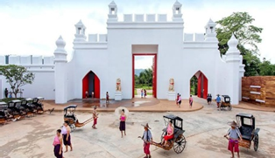
- Overnight stay at Kanchaburi Hotel

Day 4: Kanchanaburi - Bangkok (Breakfast /Lunch /DINNER BY OWN) Breakfast at hotel, after transfer to Bangkok approx. 2 hrs. lunch at Bangkok after to visit
- Wat Paknam Phasricharoen
- SONG WAT street art
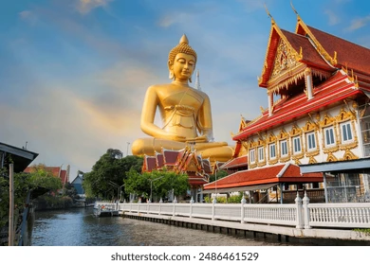
- Shopping Platinum mall, or Maboonklong , Siam paragon , Asiatique River front
- Lunch at local restaurant
- Dinner by own
- Overnight stay at Bangkok

Day5: Bangkok -Dept
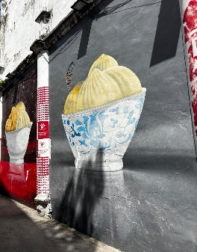
- Breakfast at Hotel
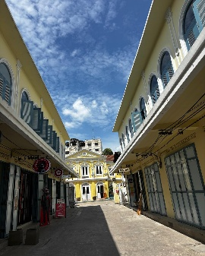
- After free leisure time and transfer to Airport for flight back your country,
- sweet Home

